**PRACTICAL TEMPERATURE CONTROLLER**

**ABSTRACT:**

This practical temperature controller controls the temperature of any device according to its requirement for any industrial application. It also displays the temperature on an LCD displays in the range of –55°C to +125°C. At the heart of the circuit is the microcontroller from PIC family which controls all its functions. An IC DS1621 is used as temperature sensor. The DS1621 Digital Thermometer and Thermostat provides 9-bit temperature readings, which indicate the temperature of the device. User-defined temperature settings are stored in a nonvolatile memory EEPROM through PIC series microcontroller .Maximum and minimum temperature settings are entered to the MC through a set of switches which are stored in the EEPROM -24C02. Maximum and minimum setting are meant for allowing any hysteresis necessary. Set button is used first and then the temperature setting by INC and then the enter button. Similarly for the DEC button. A relay is driven from the MC through a transistor driver. The contact of the relay is used for the load, shown as a lamp in the circuit. For high power heater load a contactor may be used, the coil of which is operated by the relay contacts in place of the lamp as shown.

Standard power supply of 12 volt DC and 5 volt through a regulator are made from a step down transformer along with a bridge rectifier and filter capacitor.

**BLOCK DIAGRAM**

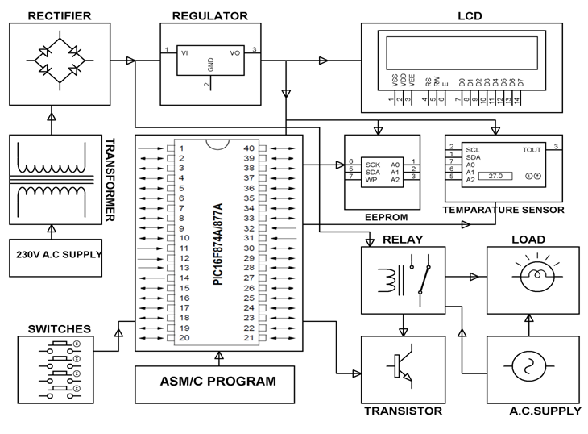

**Hardware requirement Software requirement**

Transformer. MPLAB

Voltage regulator. HI-TECH PICC Tool suite

Diodes Embedded C

Capacitor.

Resistors.

Microcontroller (PIC16F877A).

Temperature sensor (DS1621).

BC547.

Relay.

Lamp.

LCD(16x2).